Extant and recently extinct monodactyl Equids

All belong to the genus *Equus.*

a. Zebras

Grévy’s zebra (*Equus grevyi*).

Plain’s zebras (*E. burchelli* et *E. quagga*),

Mountain zebras (*E. zebra*).

b. Wild Asses (*E. africanus*).

c. Hemiones (Asiatic Wild Asses)

Hémiones (*E. hemionus*),

Kiangs (*E. kiang*).

d. Prjewalski’s horses (*E. przewalskii*).

Subspecies are listed in ‘EQUUS extant Systematic’.

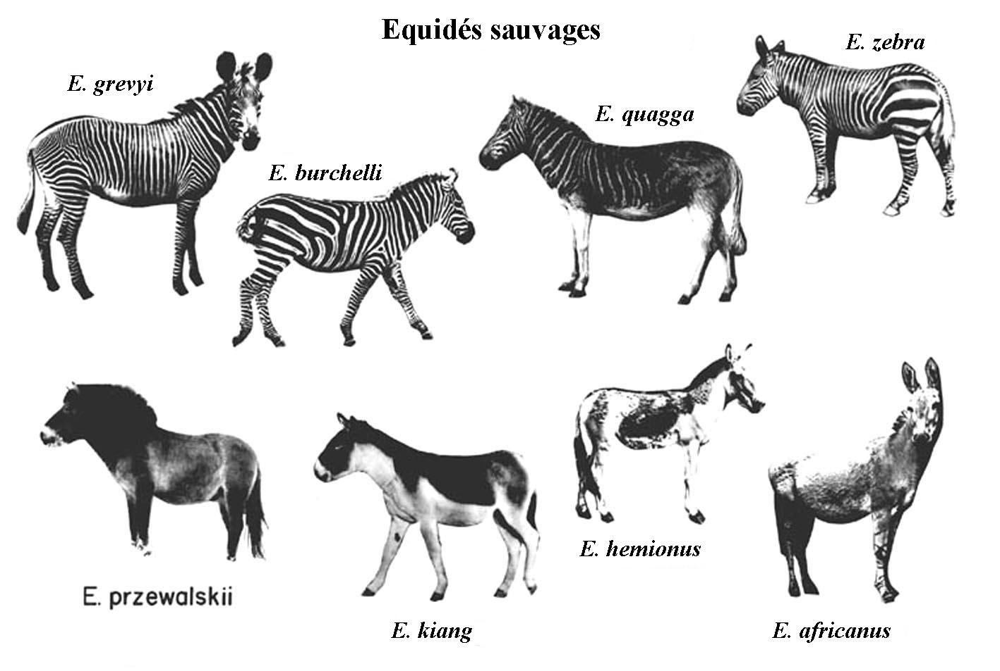

To the species listed above must be added the domestic Horses (*E. caballus*) and the domestic Asses - commonly named Donkeys - (*E. asinus)*, et their hybrids: Hinnies (resulting of the crossing of a stallion and a female donkey) and Mules (resulting of the crossing of a male donkey with a mare), as well as several other hybrids of Donkeys, Hemiones, Zebras and Horses like the young "Zébroïd" below.

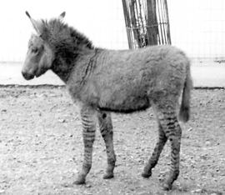

Fossil Quaternary Equids belong to the same Equus genus.

Ancient monodactyl Equids : Allohippus, Plesippus, Hippidions

Their crania differ from *Equus* by a larger brain case. Moreover, the naso-incisival notch is deeper in *Allohippus* and especially in the SouthAmerican Hippidions.

